Topic 6.5: Target Sum Expression Problem
Question
You are given an integer array nums and an integer target. You want to build an expression out of nums by adding one of the symbols '+' and '-' before each integer in nums and then concatenate all the integers.
For example, if nums = [2, 1], you can add a '+' before 2 and a '-' before 1 and concatenate them to build the expression "+2-1".
Return the number of different expressions that you can build, which evaluates to target.
Aim
To count the number of different expressions formed using '+' and '-' operators in front of each integer of the array such that the final expression evaluates to the target value.
Algorithm
- Define a recursive or dynamic programming approach to explore all possible symbol assignments.
- At each step, choose either '+' or '-' for the current element.
- Recursively compute the result for the remaining elements.
- If the sum equals the target when reaching the end, count that as a valid expression.
- Use memoization to optimize repeated subproblems.
- Return the total number of valid expressions.
Output
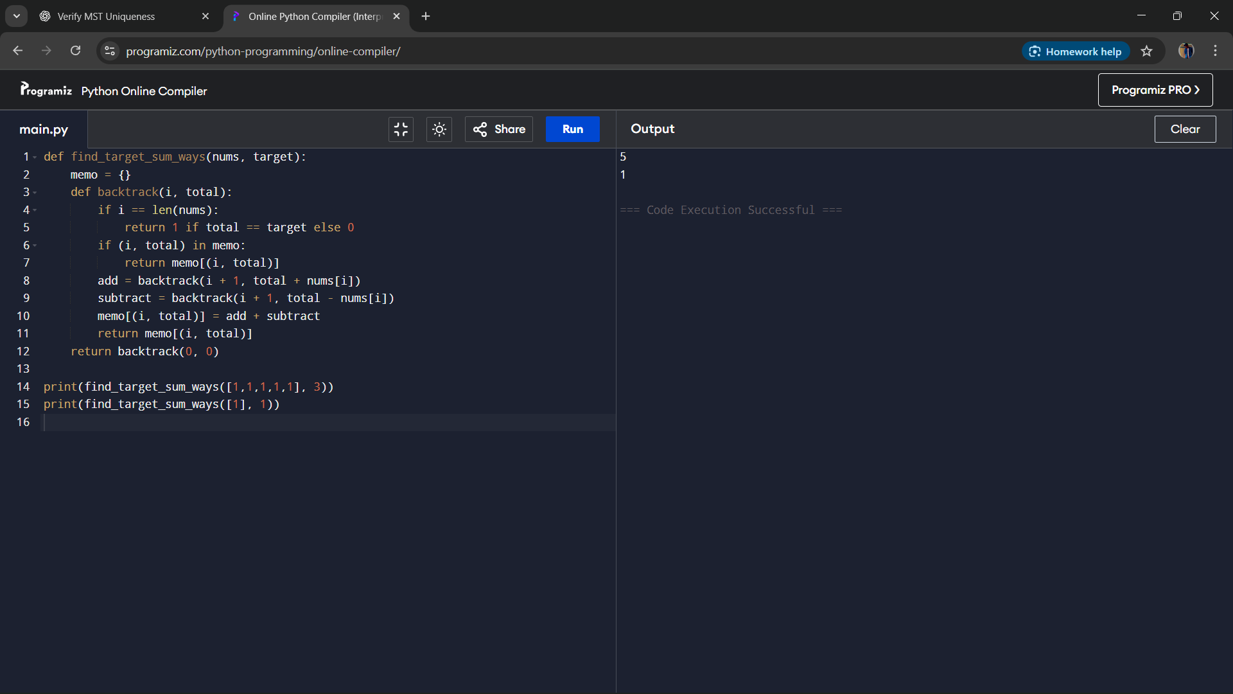
Result
The program successfully calculates the number of expressions that can be formed with '+' and '-' operators so that the result equals the target.
Performance Analysis
- Time Complexity: O(n × sum(nums)) using dynamic programming with memoization.
- Space Complexity: O(n × sum(nums)) for the memoization table.

